In the backpropogation, def backpropagation(self, X, Y, caches):

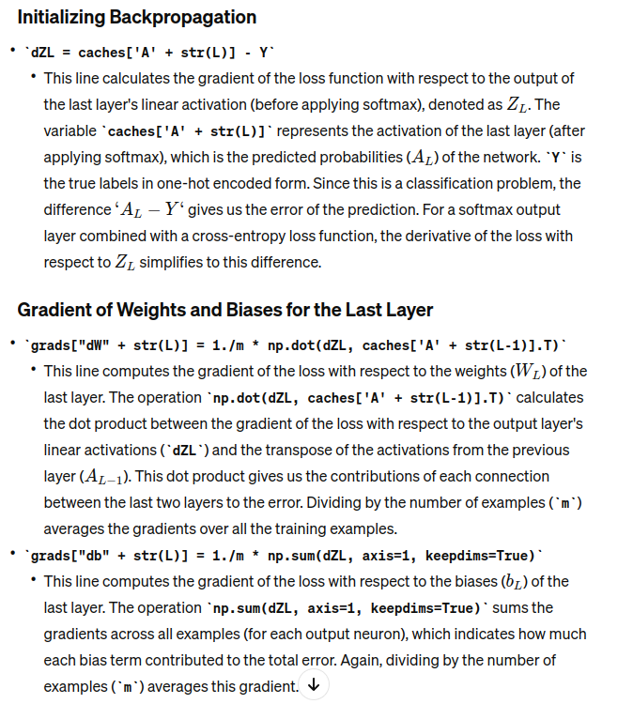

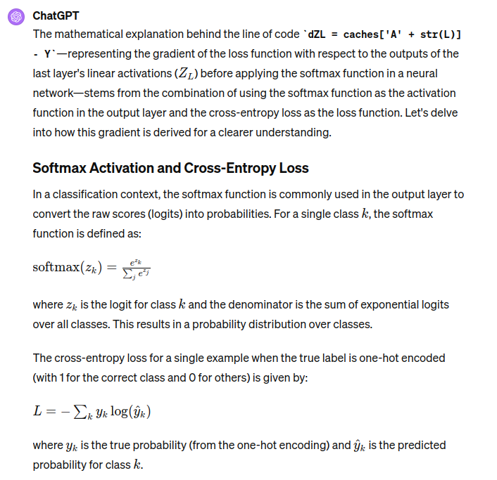

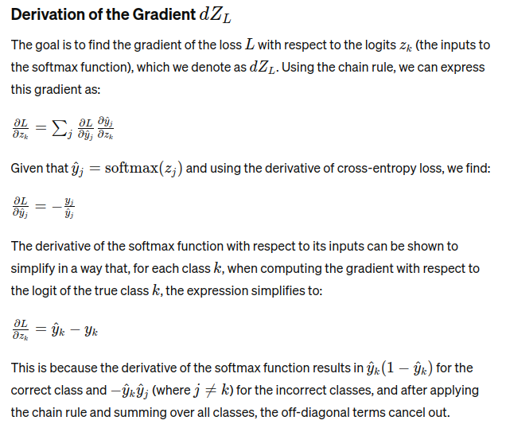

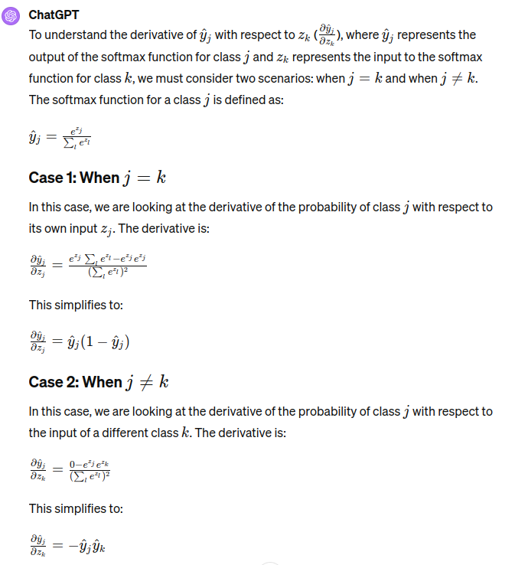

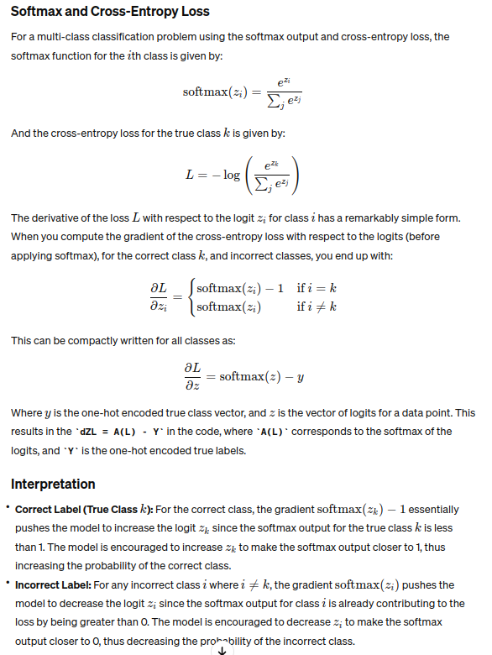

Explaination of these two lines (below) has been provided in the rough sheet
grads["dW" + str(L)] = 1./m * np.dot(dZL, caches['A' + str(L-1)].T)
grads["db" + str(L)] = 1./m * np.sum(dZL, axis=1, keepdims=True)

Explaination of this line - dA_prev = np.dot(self.parameters["W" + str(l+1)].T, dZL)
has ben given in the rough sheet
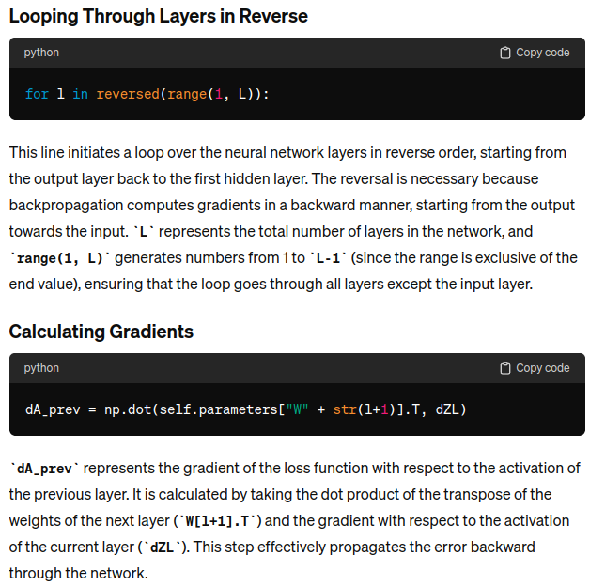

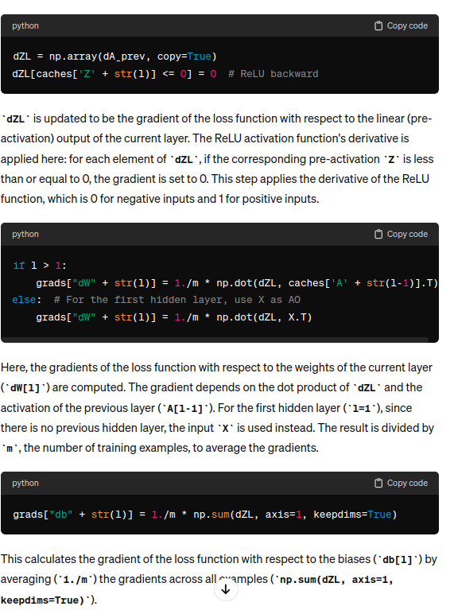
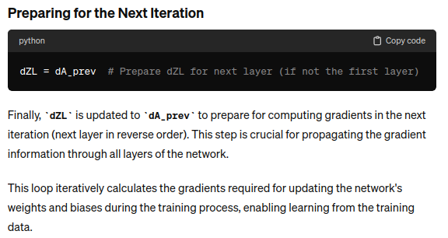

Relu backpropagation derivative output
